DESIGNATION - V 363 RESET
PID - FU1596

N 35 22 20.1

W 119 00 11.1

Recovered as described

Additional recovery notes:

Two photos.

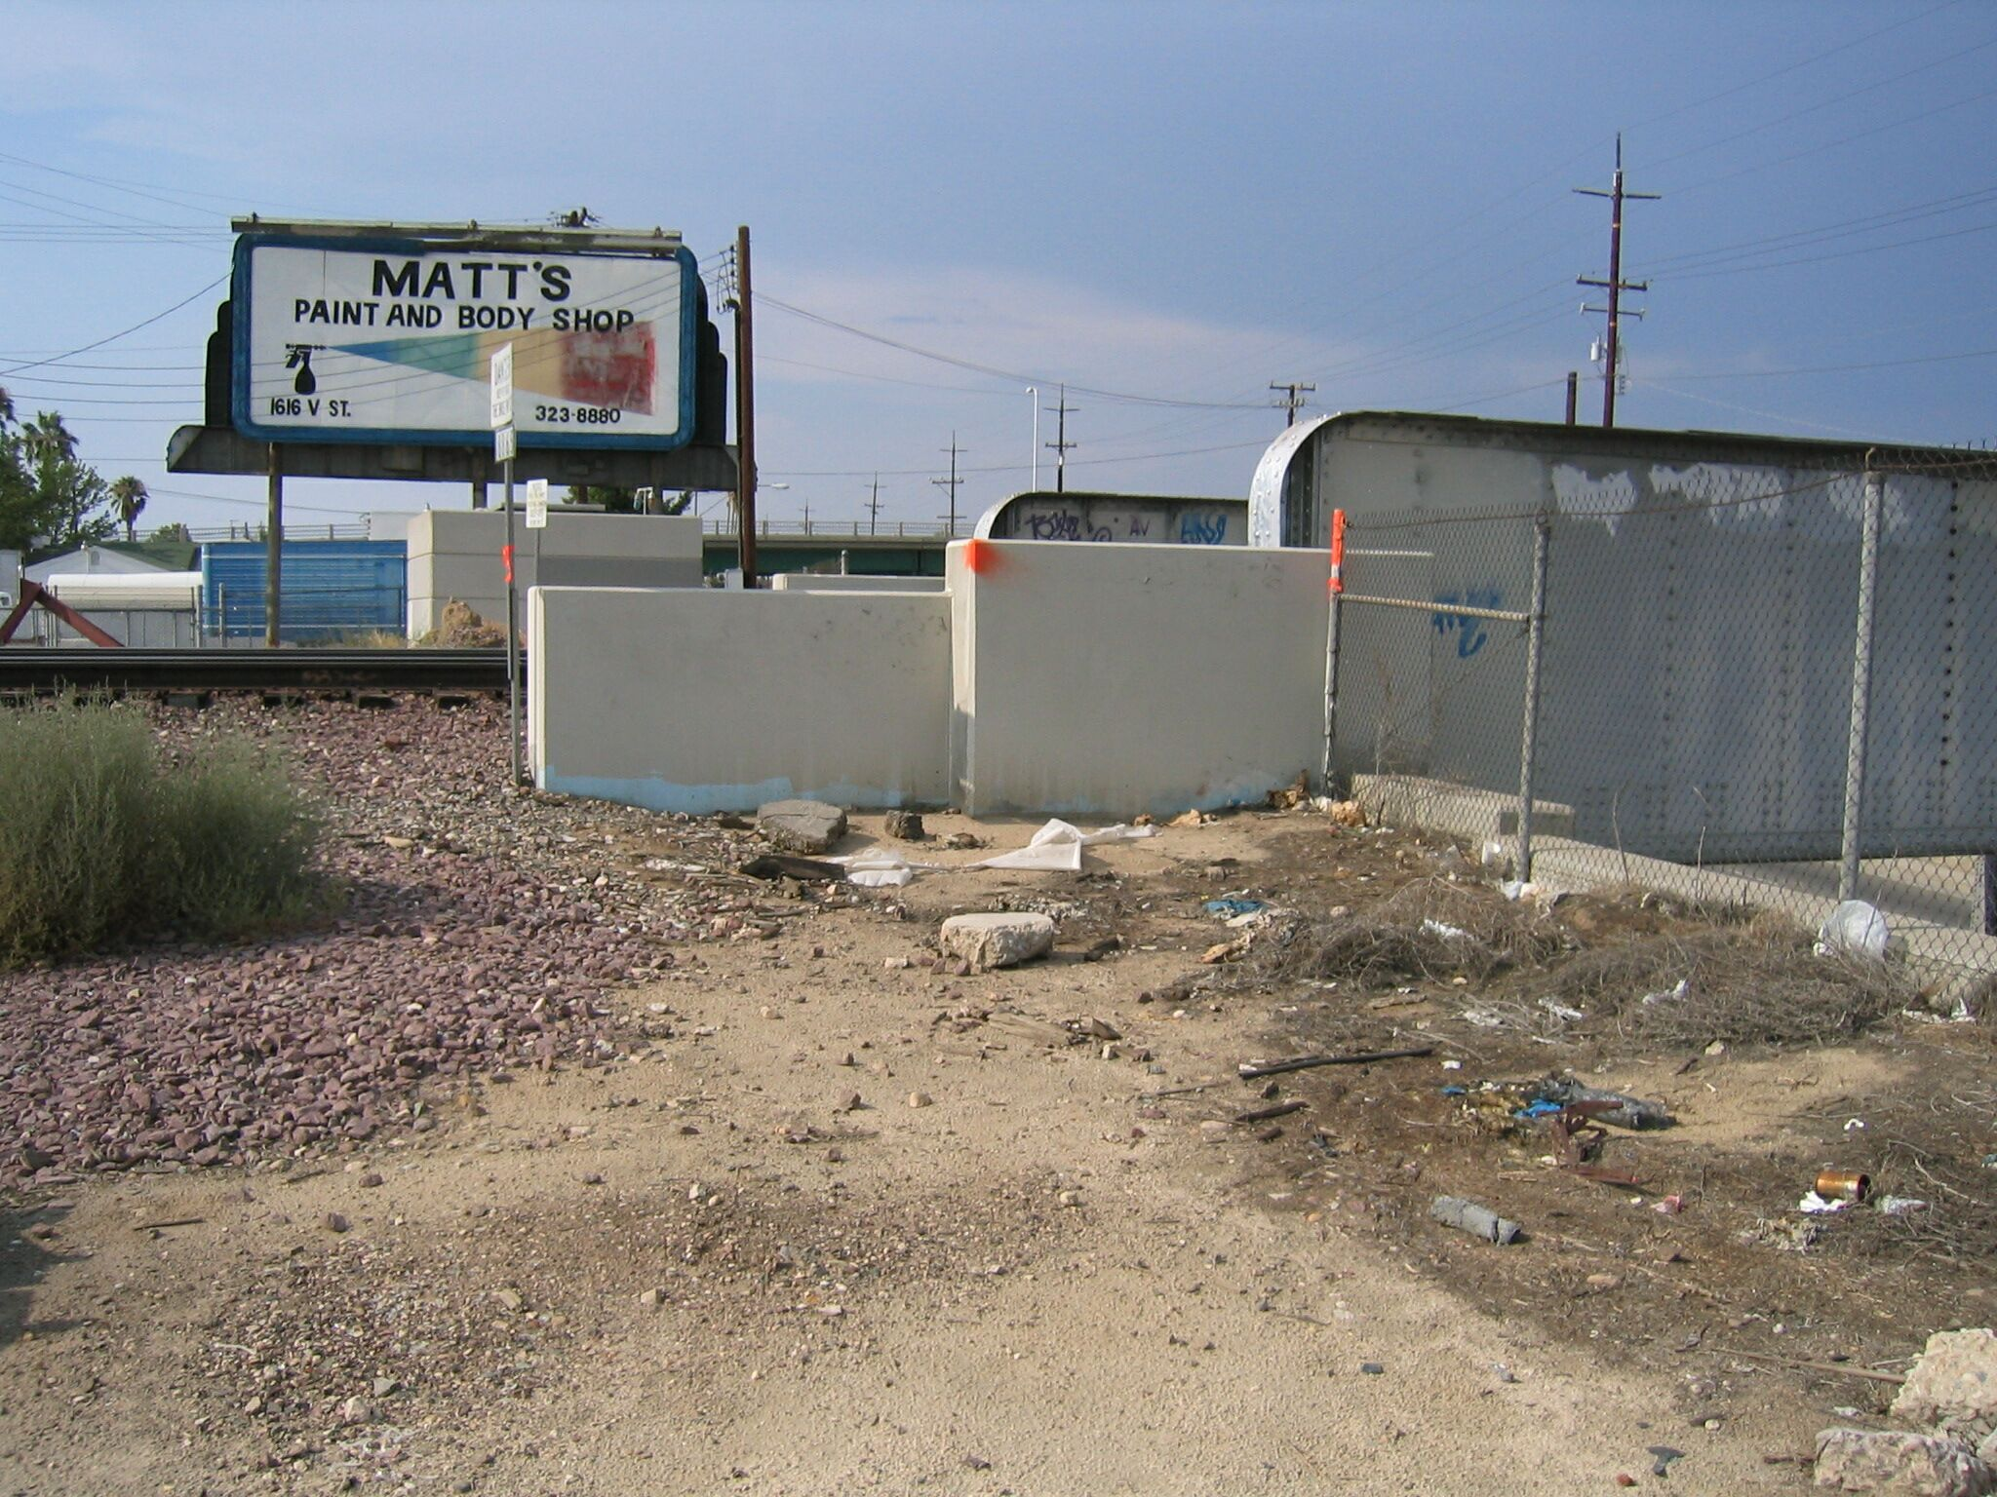
Mon

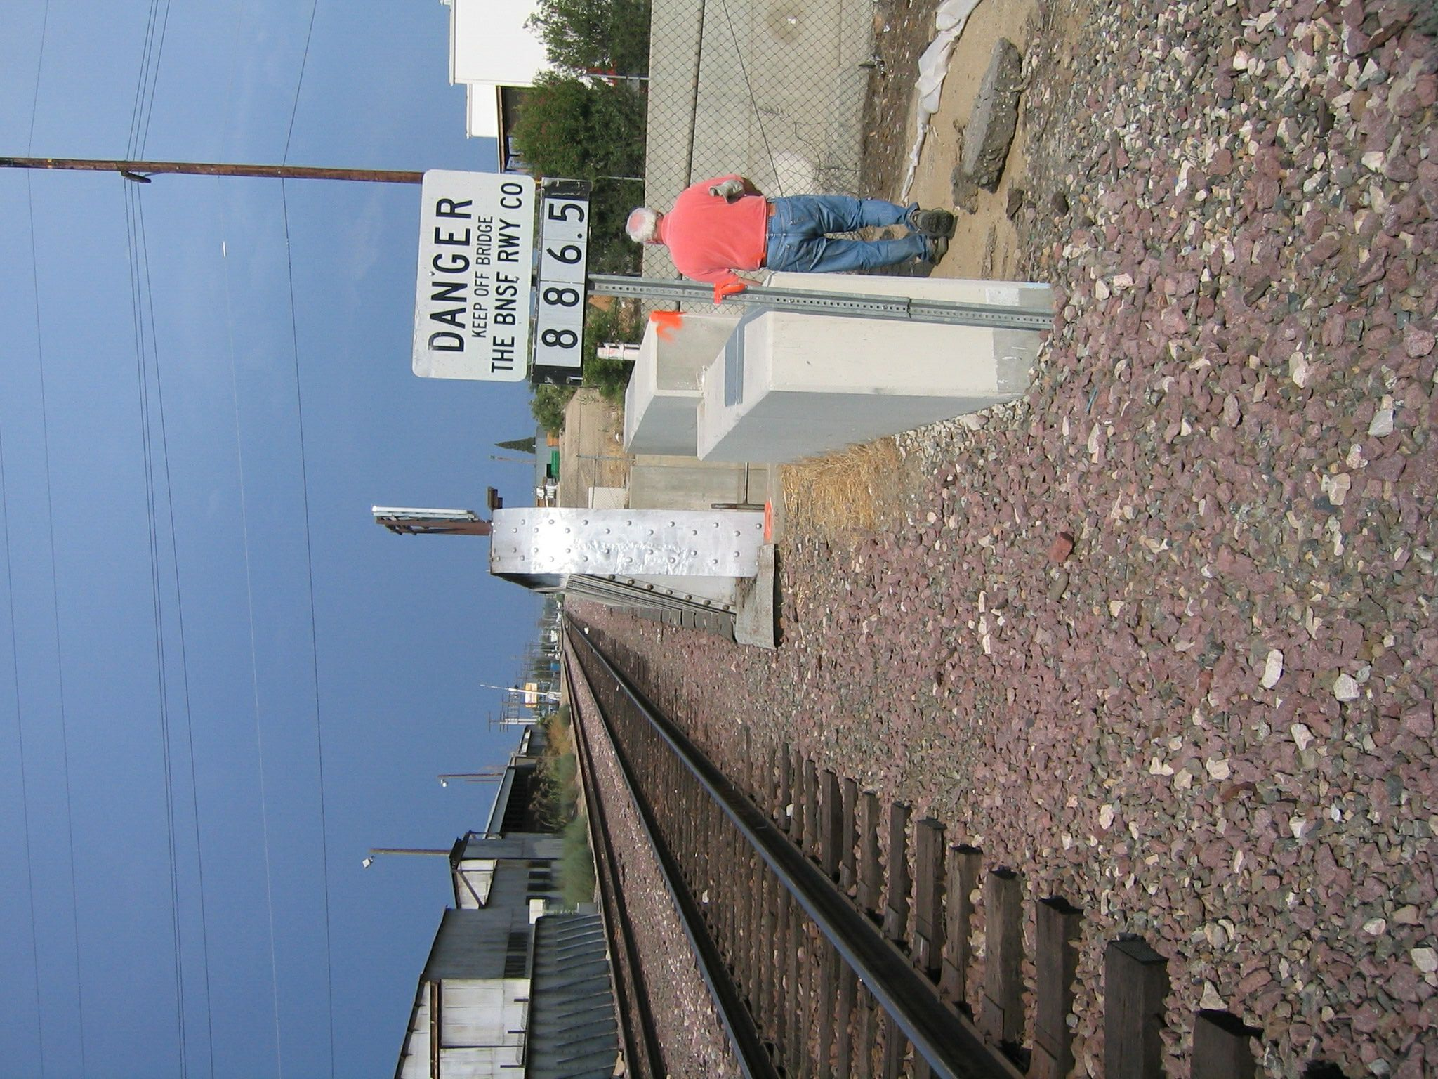
Mon

