DESIGNATION - RIVER
PID - NONE, SET NEW MONUMENT

N 35 22 55.0

W 119 02 25.5

Set new monument in pedestrian walk north side of Hwy 178 bridge over the Kern River above first peer foundation from the east end.

Additional recovery notes:
To reach from Rosedale Hwy (Hwy 178) exit at Hwy 99. From intersection of Rosedale Hwy and Hwy 99, go east 0.3 mile on Rosedale to the bridge crossing the Kern River and the station on the left. Station is located on the northwest side of bridge in the pedestrian walk.
142.5 ft west of the east end of bridge
53.5 ft northeast of C/L road
4.0 ft northeast of face of curb
- ft south west of bridge railing support.

See photo next page.

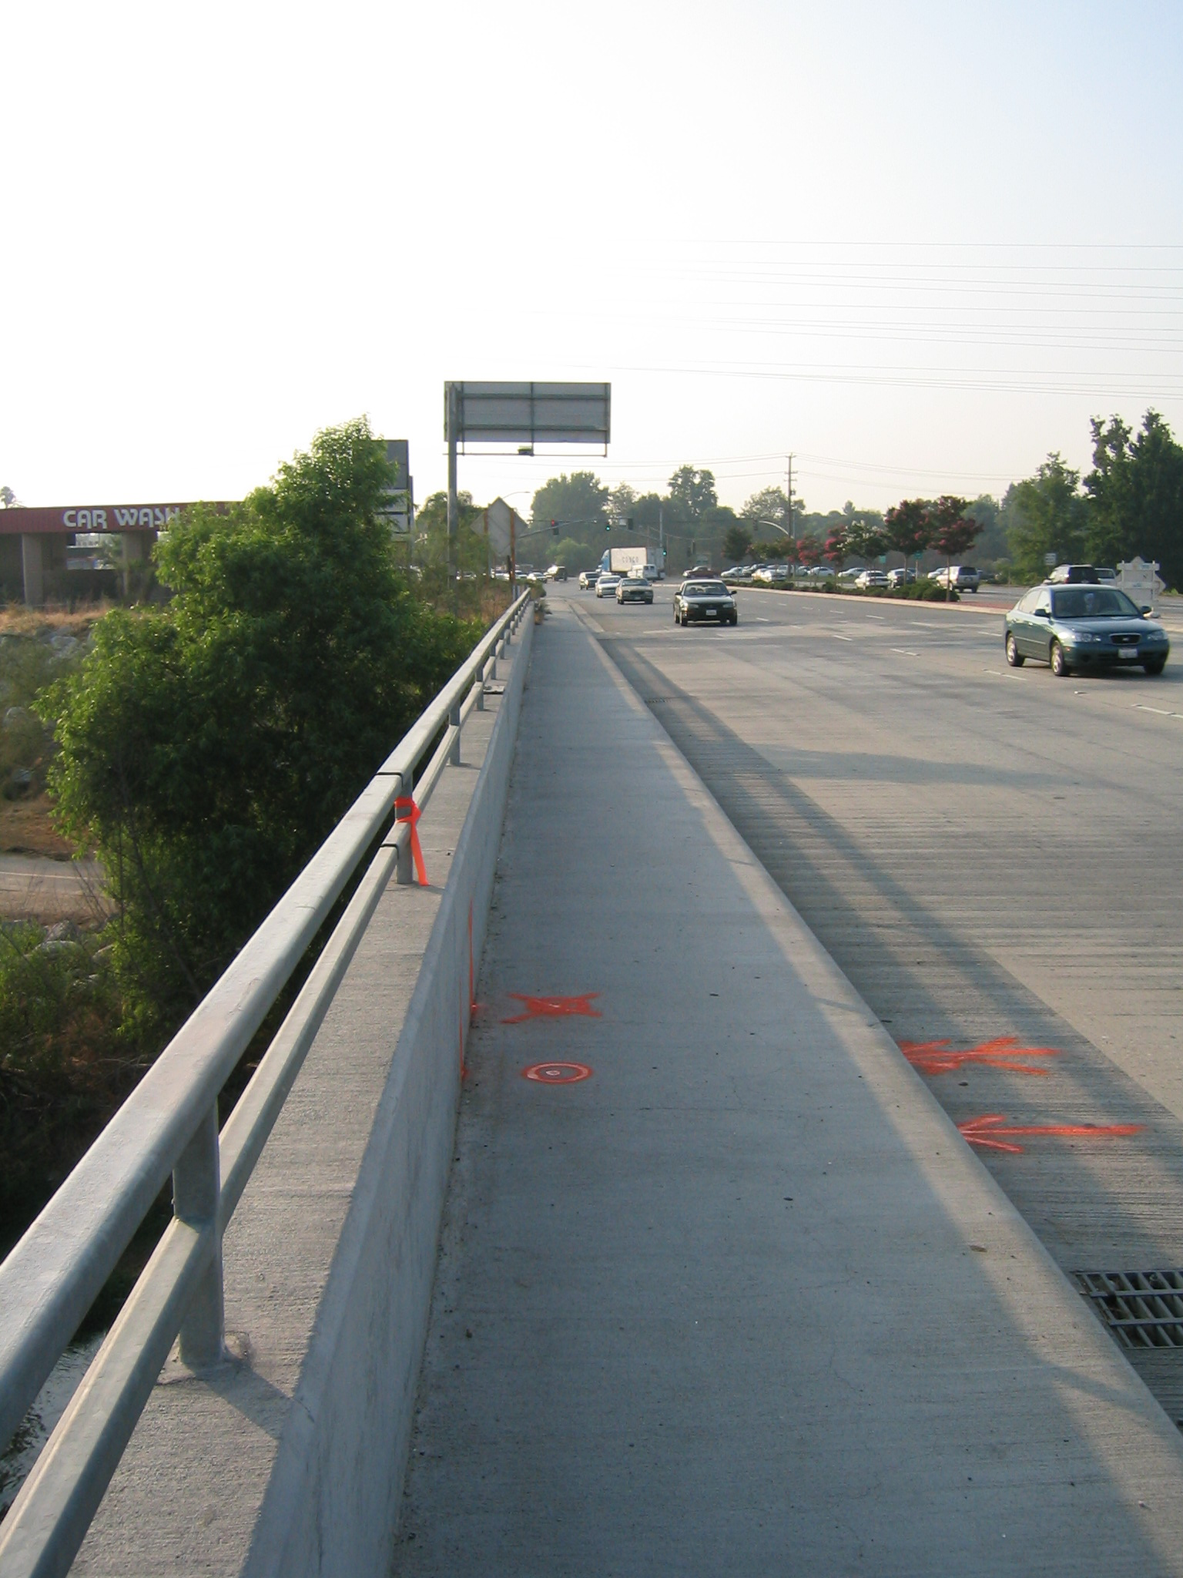
Set new
Monument

