DESIGNATION - L 363
PID - GT1504

N 36 45 01.5

W 119 48 49.0

Recovered 8-14-2003

Additional recovery notes:
NOTE: Adjustable fixed height pole needed.

Station is at the northwest corner of the railroad overpass of Belmont Dr. in Fresno. To reach from the intersection of Belmont Dr and Hwy 99 go east on Belmont Dr 0.6mi through the traffic circle, onto Thorne Ave which runs parallel to Belmont on its south side, and to the Union Pacific Railroad tracks with the station on the left.
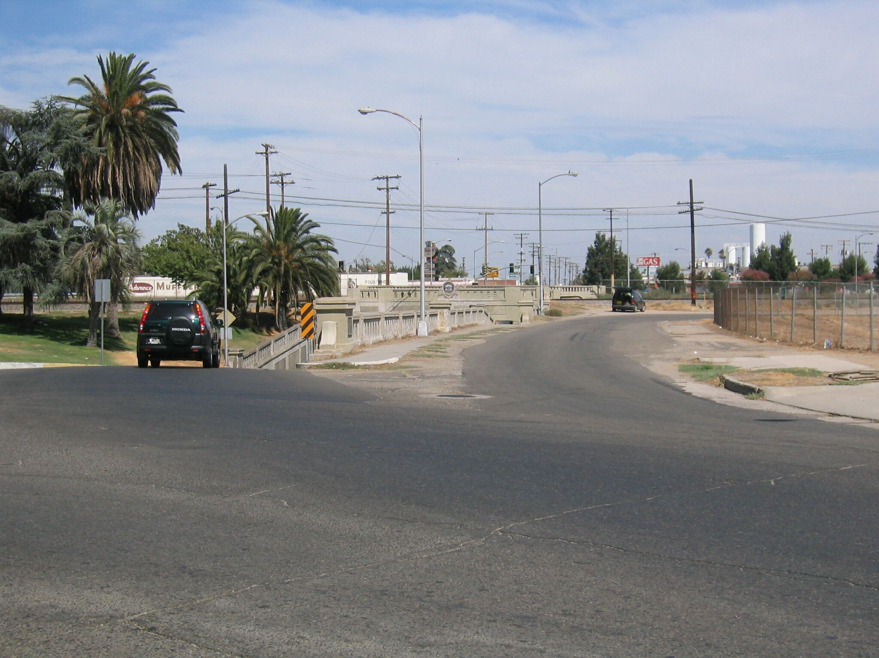
Mon

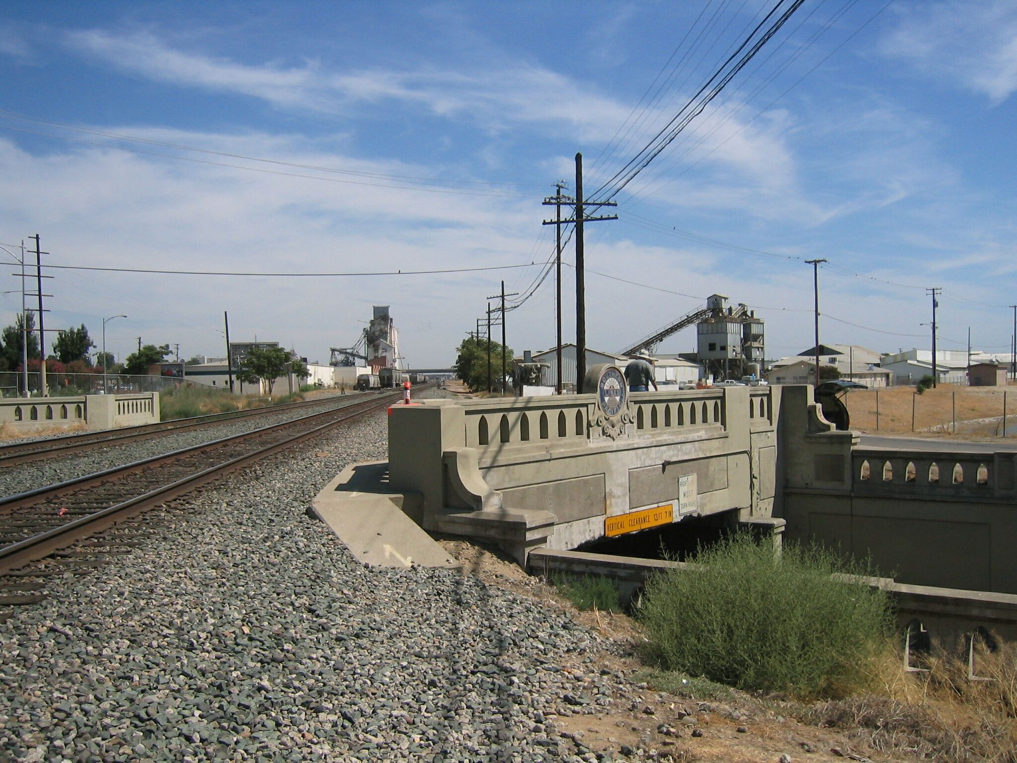
Mon

