DESIGNATION - HPGN D CA 06 LK
PID - AC6130

N 36 09 08.9

W 119 19 44.4

Recovered as described, 08-13-2003

Additional recovery notes:
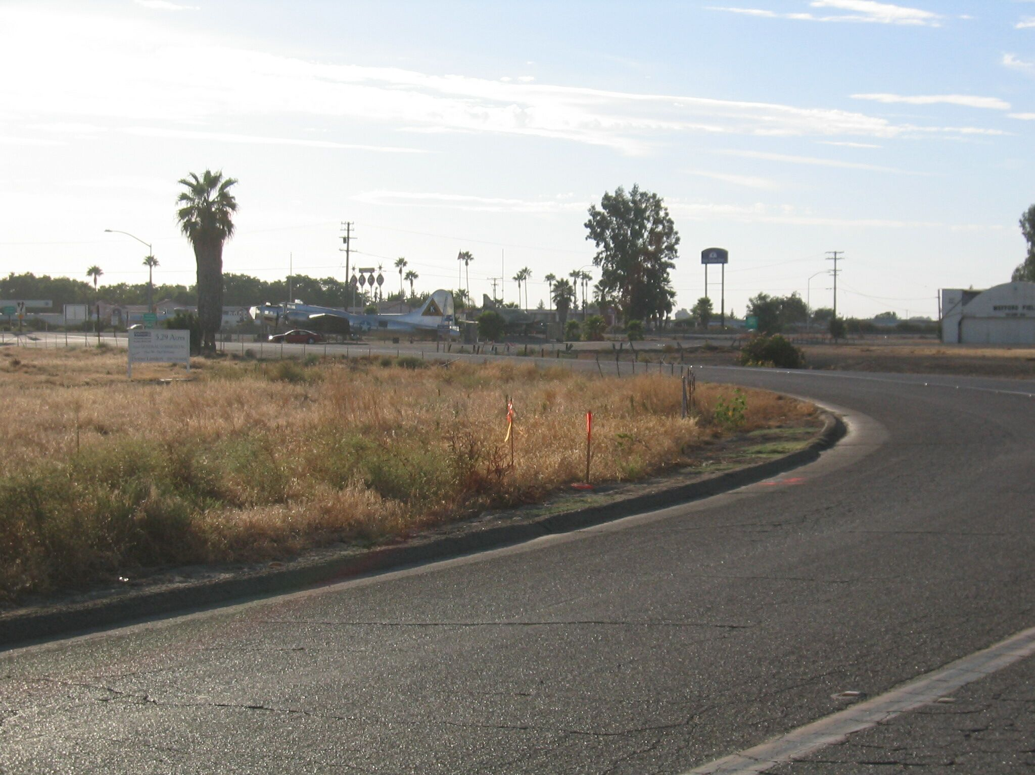
Mon

