DESIGNATION - GARDNER
PID - NONE, SET NEW MONUMENT

N 35 07 46.8

W 119 22 05.7

Set new monument on concrete wing wall.

Additional recovery notes:
Mon is located on the Gardner Field Rd. bridge over the California Aqueduct at aqueduct mile post 253.80, approximately 25mi south east of Bakersfield and 5mi east southeast of Taft.

To reach from the Hwy 166 (Maricopa Hwy) exit at I-5.
From the intersection of Hwy 166 and I-5 go west on Hwy 166 17.8mi to a paved cross road (Basic School Rd). Turn right (north) onto Basic School Rd. and go 3.0mi (crossing the California Aqueduct at 2mi) to a crossroad with Gardner Field Rd to the left. Turn left (west) onto Gardner Field Rd. and go 1.4 miles to a fork in the road with Gardner Field Rd continuing to the right. Continue on Gardner Field Rd to the northwest 2.6mi to the aqueduct crossing and the station on the left.
Set monument on wing wall at southeast corner of the overcrossing.
18.5 ft south of C/L road
1.5 ft south of south face of bridge wall/rail.

SEE PHOTO NEXT PAGE.

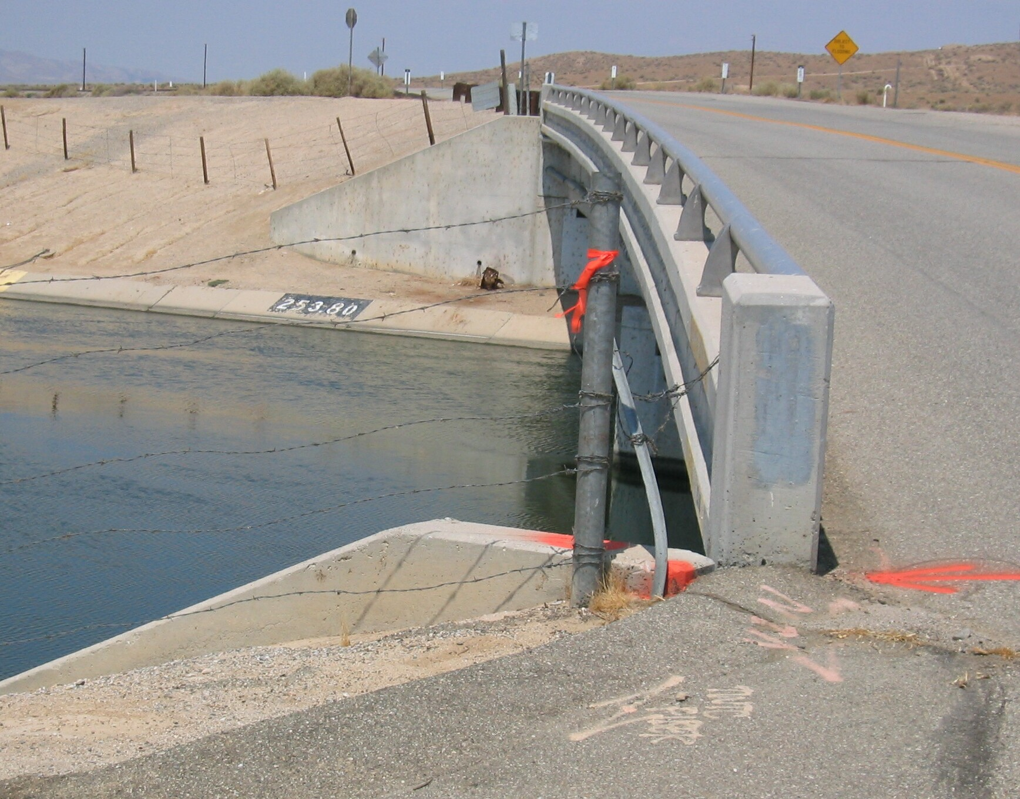
Set new
monument

