DESIGNATION - CALDWELL
PID - NONE, SET NEW MONUMENT

N 36 17 44.7

W 119 22 56.8

Set new monument in top of concrete wingwall.

Additional recovery notes:
Station is located east of and adjacent to Hwy 99 approximately 6.5mi north of Tulare and 2.6 mi south of the Hwy 99 and Hwy 198 interchange west of Visalia.

To reach from the Hwy 99 and Hwy 198 interchange go south on Hwy 99 for 2.4 miles to the Caldwell exit (Avenue 280). From the intersection of Caldwell and Hwy 99 go east 0.1 mile to a stop sign at the frontage road (Diagonal 88) and the freeway access ramps. Turn right (south) and go 0.2 miles keeping to the frontage road, left at the fork passing the Shell station on the right, to a concrete box culvert and the station on the left.
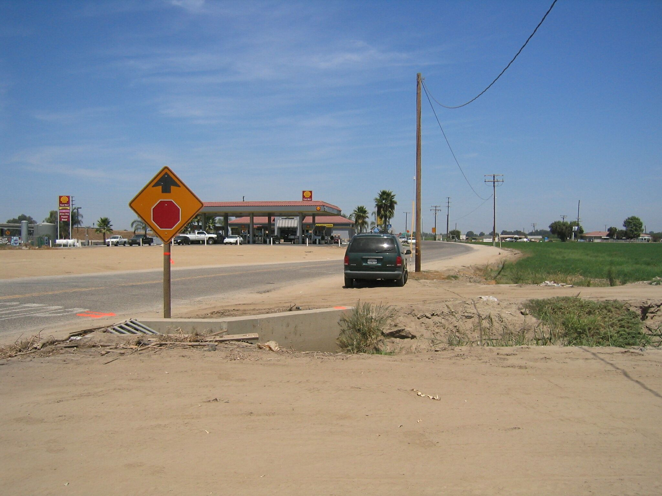
Station is at the northeast most end of the north wingwall, 28.5 feet from C/L of road, 41.5 feet northwest of a power pole with meter, and 12.0 feet south from the C/L of a dirt side road running along the ditch on its north side.
Set new
Monument

