DESIGNATION - ADAMS
PID - NONE, SET NEW STATION

N 36 38 03.8

W 119 41 32.5

Set new monument on concrete bridge abutment.

Additional recovery notes:
Station is located adjacent to Hwy 99 approximately 9 miles south of Fresno and on the northwest outskirts of Fowler.
From the intersection of Clovis Ave with Hwy 99 go south on Clovis for 0.5 mile to a cross street (Adams Ave). Turn left (east) and go 0.4 miles crossing Hwy 99 to the station on the right. Station is located on the southeast side of the overpass in the pedestrian walkway. Set monument 19.5 feet south of the C/L of Adams, 17.8 feet west of the east end of pedestrian walk, and 3.9 feet south of the north face of the south curb.

See photo next page.

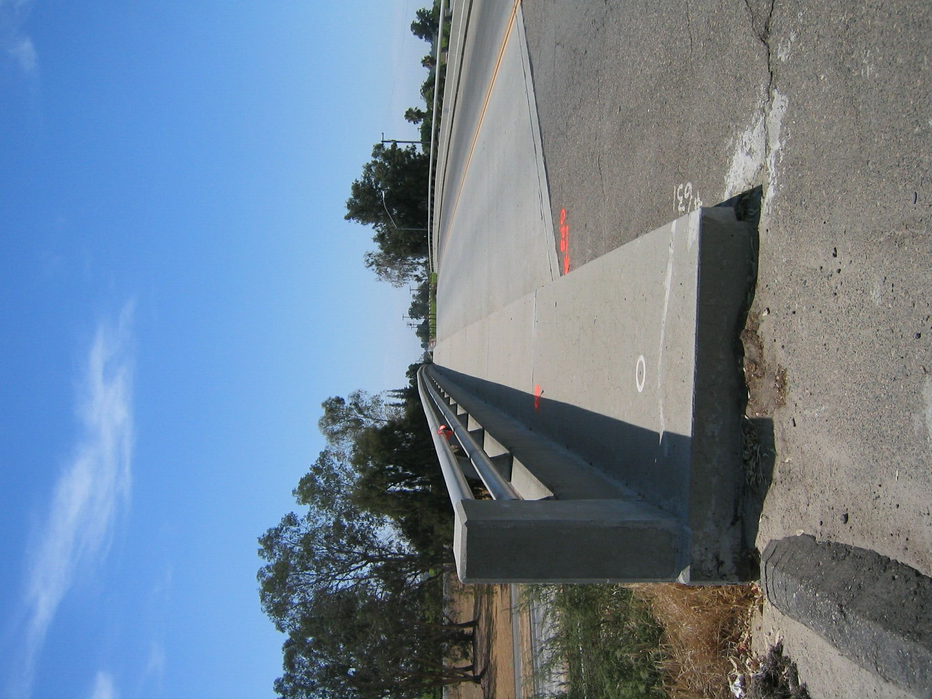
Set new
Monument

